Team Project Manual

20800128 김윤태

20900132 김용진

20900194 김태이

1. Background
   1. Intention
      * implementing animation feature used in Prj.2
   2. Purpose
      * Making Squash game
2. Main Functions
   1. Ball bouncing in the box
   2. Racket to hit the ball
3. Semi Functions
   1. Time check
   2. Stage level
   3. Irregular bounce
   4. Fog effect
   5. Sound effect
4. Actual Implementation
   1. Movement of the ball

* Increment x, y, z values
* Apply values to each coordinate
* Example

0 ~ 1000 -> -500 ~ 0 ~ 500 -> 500~0 / 0 ~ 500 -> 20~0 / 0~ 20

1. Screen Explanation

2

5

3

4

1

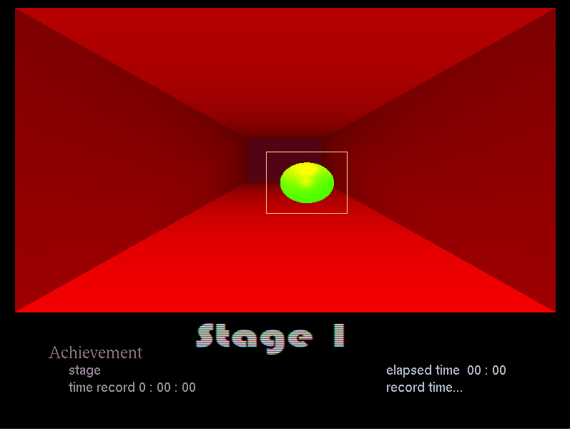

1. reflecting wall
2. ball
3. stage and time record of achievement
4. current stage
5. current flowing time and previous record

5. Feature implementation

A. Stage level

When level goes up to 3, speed of the ball increases.

At level 3, irregular bounce occurs

At level 4, fog appears in the nearby side

At final level, fog moves

B. Sound implementation

Sound plays corresponds to each situation

6. How to play

1. When you click, the ball start to move
2. you have to hit the ball when ball approaches you
3. you can move the level by the menu which pops up when you click the right button.